**Obstacle Owen 2.0v**

**GAME DESIGN DOCUMENT**

**Game Overview**

**What is the Game About?**

This a obstacle course game which test the player agility

**Game Theme**

**Game Genre**

Multi-stage 3D, First person platform

**Game Platform**

PC

**Game Story**

**Target Audience**

(Teenagers, Adults)

**ART**

**Characters**

**Hero Characters**

**Villain Characters**

**NPC (Non Playable Characters)**

|  |  |  |  |  |
| --- | --- | --- | --- | --- |
| **N.O** | **Name of Character** | **Type** | **About the Character** | **Abilities** |
| **1** | Jeanne | archaeologist | Jeanne is a famous archaeologist, before she became archaeologist, she serves in US Marine Corp. and she is specialized with many different weapon and been through lots of mission and operation but after her dad death she left US Marine and pursue her dad legacy so with the money she earn from her past job she went it university to study archaeology. | Weapon specialize |

**Environments**

**REGIONS:**

**R1: The Lost City (Atlantis)**

**R2: Sandy Desert**

**R3: Ice and Snow**

Discuss the overview what is Region 1 about. (Ice and Snow lands, Difficult to see, Full of Ice Giants etc)

|  |  |  |  |  |
| --- | --- | --- | --- | --- |
| **N.O** | **Name of Region** | **Levels** | **About the Region** | **Enemies** |
| **1** | The Lost City (Atlantis) | There will be 2 level | According to the Greek mythology, Atlantis is one of most powerful naval country but the king hungry for more power so the Research and Development team conduct research test on a small piece of Poseidon trident, during their research there was a sudden large earthquake that sunken the Atlantis and till this day people still believe that Poseidon is the one who cause the earthquake to stop the king for harnessing for more power. | Undead Fish man (small enemy’s) |

**UI DESIGN**

The Design for the start page is going to be more colourful and having the game title at the front so that it will attract more players and get the player more excited to play the game.

For the Main Menu we are going to implant basic menu like Story selection, option and credit.

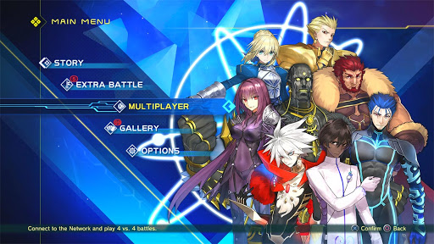

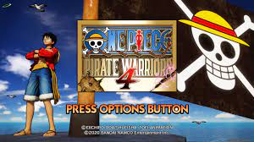

**DESIGN**

**LEVEL DESIGN**

|  |  |  |  |  |
| --- | --- | --- | --- | --- |
| **N.O** | **Region** | **About the Level** | **Objectives of the Level** | **Challenges of the Level** |
| **1** | 1 | This level is where Jeanne found out that the lost city not welcoming but she doesn’t want to leave empty handed so decided to fight through a horde of fishmen and explore the main capitol of the lost city and in hope of finding any ancient relic or any miss history that was untold to the world | 1. Clear out all the enemy’s 2. Find a way deep into the castle | 1. Enemy 2. Limited air |

**SOUND DESIGN**

**Background Sound**

Discuss how many background sound will be in the game (3-5) and how it will be used in the game

BG Sound 1: To be played when player is fighting enemies (Intense)

BG Sound 2: To be played when player is exploring the lands

**Sound Effects**

Discuss the main sound effects to be used for the game

Sound FX 1: Attack Sound

Sound FX 2: Jumping Sound

**PROGRAMMING**

**GAME SYSTEMS**

Player must kill enemy’s in each level of the region and find ways to procced to the next level of the stage, each stage player can find different guns that can help them throughout the whole game.

To clear each level, they must kill the main boss of the stage and procced to the next stage until they escape the region.

Every choice that the player made can affect the game ending.

**GAME MECHANICS**

Discuss the game mechanics to be used for the game. This includes the attack moves, defend moves, combo moves etc of the hero and enemy characters. Also include the triggers such as pick up items (speed pick up, health pick up, weapon pick up) etc. Map out the game controls to the key board and mouse image seen below.

**Movement**

W: Forward

A: Left

S: Backward

D: Right

Space: Jump

C: Crouch

**Control**

Left Click: Fire/Swing sword

Scroll Wheel/Hold down: Weapon Change

F: Pick up item

R: Reload

M: Inventory

**MARKETING**

**SOCIAL MEDIA:**

Discuss the different social media pages that the game will have and the type of content that will be put there

**Facebook:** Images, Videos, Game Play Trailer

**Instagram**

**YouTube:** Development Vlogs, Game Play Trailers

**WEBSITES/FORUMS**

Discuss the different websites or forum pages where you will write in for your game to be displayed. Identify 5 different websites or Forums where you can display your game.

<https://www.pcgamer.com>

<https://www.game.co.uk/>

**MANAGEMENT**

**SCHEDULE OF GAME PRODUCTION (8 WEEKS)**

|  |  |  |
| --- | --- | --- |
| WEEK | Things to be Start On | Things to be Completed |
| Week 1 | Concept Art of Characters, 3D Models of Characters, | NA |
| Week 2 | 3D Animation of Characters, Basic Level Design | Concept Art of Characters, 3D Models of Characters, |
| Week 3 | Programming, Stage Design | Movement and Control, Progressive of stages, Win and Lose, great ending and bad ending |
| Week 4 | Game testing and finalizing | Fixing any bugs on the game and making sure the game run smooth |
| Week 5 |  |  |

**REFRENCES**

Add the references (with accompanying images and website link) of the game assets used for your game.

Player Model: <https://sketchfab.com/3d-models/woman-pose-8a8ebf6aeb704cc7964d56b0c6e90f50>

Region Picture: <https://www.ancient-origins.net/myths-legends/russian-atlantis-tomb-raider-s-invisible-city-kitezh-was-real-place-006122>

UI Picture reference:

Fate/Extella link (Anime, Action, Hack and Slash)



One Piece Pirate Warriors 4 (Anime, Action, Hack and Slash)